[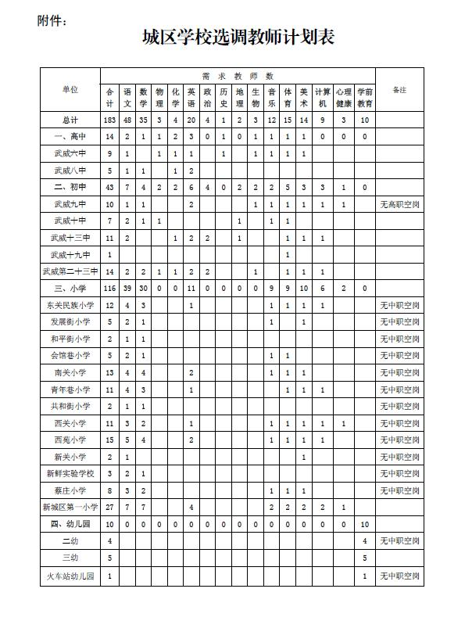](http://www.lzqedu.gs.cn/Article/UploadFiles/201607/2016072811291057.jpg)